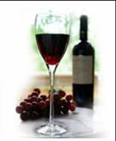Space Park Enology Club Presents:

California “Big Reds” with

Bill Hirsh of Cielo Wineyards

Friday, March 16th, 2012, 7:30 pm - Embassy Suites Hotel, El Segundo

The Space Park Enology Club is pleased to present a tasting of California “Big Reds”. The term “Big,” when referring to wine, means a wine that has full, rich flavors. There’s an array of wines that fit the “Big Red” category and we’ll taste a few of them. This event will feature Cabernet, Merlot and Syrah, three of the big hitters in red wine.
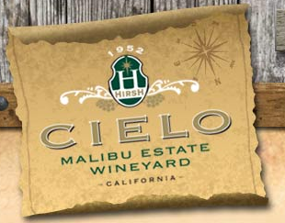
All of our wines will hail from California, a major grower of red wine grapes. Nearly three-quarters the size of France, California accounts for nearly 90 percent of the entire American wine production. If California were a separate country, it would be the world's fourth-largest wine producer!

To help us navigate through the sea of California reds is Bill Hirsh from Cielo Wineyard (yes, the spelling is correct). Cielo is located in the Malibu foothills and produces exceptional estate grown wine as well as wines from selected vineyards in Northern California. Cielo has won numerous awards for their big red wines - one being a Double Gold at the 2008 San Francisco International Wine Competition for their 2006 Syrah.

https://www.cielofarms.com/

Come taste delicious red wines from the great state of California and answer the age old question –“is bigger better?” Friday, March 16, 7:30 pm at the Embassy Suites Hotel, 1440 East Imperial Ave, El Segundo, CA 90245, just west of Sepulveda. An assortment of bread, fruit and cheese will be served. Sign up early to ensure your spot!
Reservations by email are required. Deadline for reservations or cancellations is Friday, March 9th!
EMAIL TODAY:  maryannwines@yahoo.com  and then mail checks and reservations to:  NGC Space Park Enology Club  Attn: Mary Ann Hetherington  One Space Park S/1156 (Enology)  Redondo Beach, CA, 90278  (310) 332-4262 | The price of this event is:  $30 for members  $35 for guests  Please make checks payable to:  Enology Club  Must be at least 21 years of age to participate in this event

California “Big Reds” on March 16, 2012

Name Member? Yes No

Name Member? Yes No

Please select confirmation option:
Email Day Phone _

Email Day Phone _

